Global Styling (Polished Dark Theme)
While built in Streamlit, the design aims for a modern, component-based feel using Streamlit's native Theming API or custom CSS (for minor padding/border-radius tweaks).
- Theme: Modern Dark Theme (Background: #0E1117, Widgets: #262730, Accent: #FF4B4B)
- Typography: Clean sans-serif (Streamlit's default Inter).

VIEW 1: Main Results Dashboard
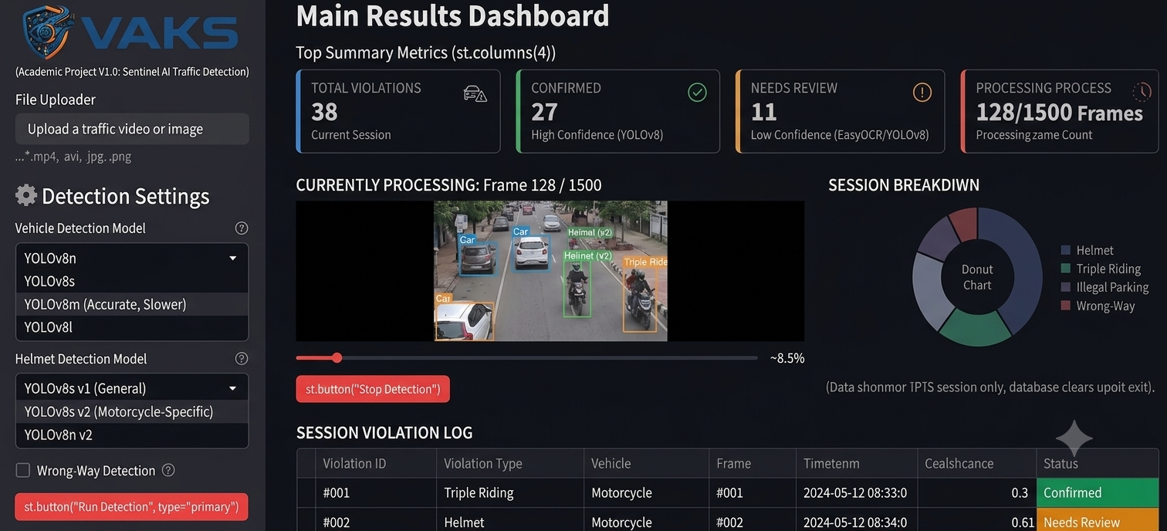
(This is the default view once detection is triggered in the sidebar.)
Sidebar (Configuration & Control) Streamlit's st.sidebar. Only absolute controls.
- App Logo & Title: st.sidebar.image displaying the custom VAKS shield logo, followed by a markdown caption: "(Academic Project V1.0: Sentinel AI Traffic Detection)".
- File Uploader: st.file_uploader. Accepting *.mp4, .avi, .jpg, .png. Label: "Upload a traffic video or image".
- Detection Settings: A header "Detection Settings" (with a gear icon).
  - Vehicle Detection Model: st.selectbox containing YOLOv8 model options (e.g., "YOLOv8m (Accurate, Slower)").
  - Helmet Detection Model: st.selectbox containing YOLOv8 model options (e.g., "YOLOv8s v2 (Motorcycle-Specific)").
  - Wrong-Way Detection: st.checkbox("Enable Wrong-Way Detection") with a tooltip helper.
- Trigger Button: st.button("Run Detection", type="primary") located at the bottom.
Main Body Area (The Dashboard)
Row 1: Top Summary Metrics (The "Value Cards") Using st.columns(4) with stylized containers for a modern look.
- Card 1 (Blue Accent): TOTAL VIOLATIONS | [Big Number, e.g., 38] | Subtext: Current Session | (Icon: Car/Warning)
- Card 2 (Green Accent): CONFIRMED | [Big Number, e.g., 27] | Subtext: High Confidence (YOLOv8) | (Icon: Check Circle)
- Card 3 (Orange Accent): NEEDS REVIEW | [Big Number, e.g., 11] | Subtext: Low Confidence (EasyOCR/YOLOv8) | (Icon: Alert Circle)
- Card 4 (Red Accent): PROCESSING PROGRESS | [Big Number, e.g., 128/1500 Frames] | Subtext: Processing Frame Count | (Icon: Clock)
Row 2: Live Processing & Analysis Using st.columns([2, 1]) — larger column for video, smaller for chart.
- Left Column (2x width): Live Preview & Progress
  - Title: "CURRENTLY PROCESSING: Frame [Frame#] / [Total Frames]"
  - Live Preview Window: (st.image updated in loop). Displaying the CURRENT processed frame with overlaid bounding boxes (YOLOv8 output). This is a replay of the uploaded file, not a live feed.
  - Progress Bar: Standard st.progress bar (calculated by current_frame / total_frames).
  - Stop Button: Standard st.button("Stop Detection") (Red style), located below the video window to end the processing loop.
- Right Column (1x width): Violations by Type (This Session)
  - Title: "SESSION BREAKDOWN"
  - Chart: Simple Donut Chart (e.g., using st.plotly_chart via Plotly Express, configured with dark theme).
  - Scope: Distribution of the 4 types ONLY: (Helmet, Triple Riding, Illegal Parking, Wrong-Way).
  - Constraint Note: Chart explicitly labeled: "(Data shown for THIS session only, database clears upon exit)."
Row 3: Violation Log Table Standard st.dataframe or st.data_editor in full width.
- Title: "SESSION VIOLATION LOG"
- Data Source: The current, session-cleared Pandas DataFrame.
- Columns Provided: Violation ID (e.g., #001), Violation Type, Vehicle (car/bus/truck/motorcycle), Frame, Timestamp (time elapsed in video), Confidence (e.g., 0.92), Status.
- Functional Polish (Custom CSS for Status Column): The Status column is key. High confidence detections get a distinct green background cell ("Confirmed"). Low confidence gets an orange background cell ("Needs Review"). This immediately highlights the two-tier system for evaluation.

VIEW 2: Violation Detail View
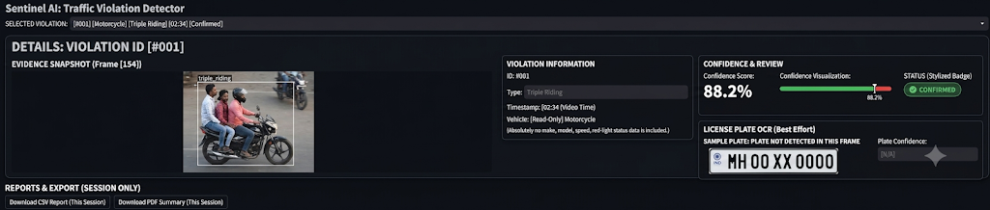
(This view is accessed when a user selects a single violation ID from the log table in View 1, utilizing Streamlit's st.radio or st.selectbox for index selection below the table.)
The Detail Panel ContainerTitle: "DETAILS: VIOLATION ID [#001]" (With custom styling like borders or shadows for component feel).
Detail Panel Layout (st.columns([1, 1]))
- Left Column: Evidence Image
  - Title: "EVIDENCE SNAPSHOT (Frame [Frame#])"
  - Image Window: st.image. High-quality cropped snapshot of the CURRENT DETECTED VEHICLE ONLY, showing the bounding box overlay (Helmet Missing, Triple Ride, etc.).
- Right Column: Specific Information Panels (Stacked)
  - Panel 1: "VIOLATION INFORMATION"
    - ID: #001
    - Type: [Text Input Box, Read-Only] "Triple Riding"
    - Timestamp: [Read-Only] 02:34 (Video Time)
    - Vehicle: [Read-Only] Motorcycle
    - No other data (no make, model, speed, red-light status).
  - Panel 2: "CONFIDENCE & REVIEW"
    - Confidence Score: (Custom CSS component, large bold number) "88.2%"
    - Confidence visualization (e.g., a simple color bar from green to red, indicating where 88.2% falls).
    - STATUS (Stylized Badge): (Using st.markdown with custom CSS).
      - If Confidence > Threshold: GREEN "CONFIRMED" badge.
      - If Confidence < Threshold: ORANGE "NEEDS REVIEW" badge.
    - Constraint Note: Absolutely no case-management buttons like "Notes", "Mark as Resolved", "Add Watchlist". This data is static.
  - Panel 3: "LICENSE PLATE OCR (Best Effort)"Using st.columns(2) for aesthetic.
    - Case A: OCR Successful: Display the best-effort OCR text in large bold font.
    - Case B: OCR Unsuccessful: Display a standard graphic placeholder (like image_6.png or image_7.png), but CLEARLY AND VISUALLY LABELED with large Markdown text above or overlaid: "SAMPLE PLATE: PLATE NOT DETECTED IN THIS FRAME". The plate is a visual placeholder only.
    - Plate Confidence: (If Case A, e.g., 72.1%. If Case B, N/A).

VIEW 3: Reports/Export Area
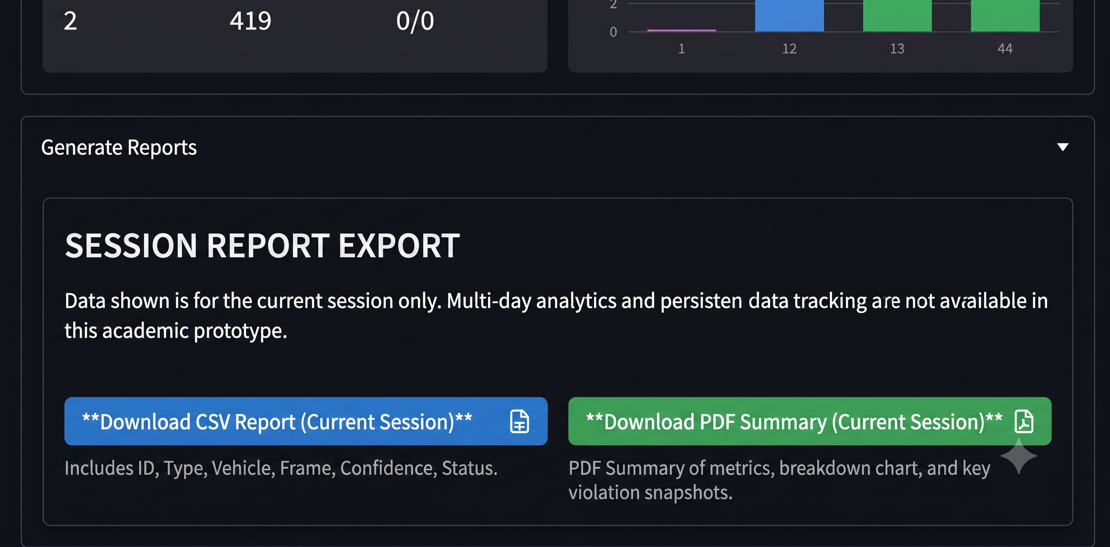
(Standard full-width Streamlit section at the bottom of View 1, often inside an st.expander named "Generate Reports.")
Report Container PanelTitle: "SESSION REPORT EXPORT" (A clean panel component with modern styling).Constraint Header: "Data shown is for the current session only. Multi-day analytics and persistent data tracking are not available in this academic prototype." (Ensuring full academic transparency).
Download Panel Layout (st.columns(2))Using standard st.download_button functionality.
Download Button 1 (Left Column) | Download Button 2 (Right Column)
st.download_button(...) | st.download_button(...)
Button Label: "Download CSV Report (Current Session)" | Button Label: "Download PDF Summary (Current Session)"
Subtext: Includes ID, Type, Vehicle, Frame, Confidence, Status. | Subtext: PDF Summary of metrics, breakdown chart, and key violation snapshots.
(Icon: File SpreadSheet) | (Icon: File PDF)

